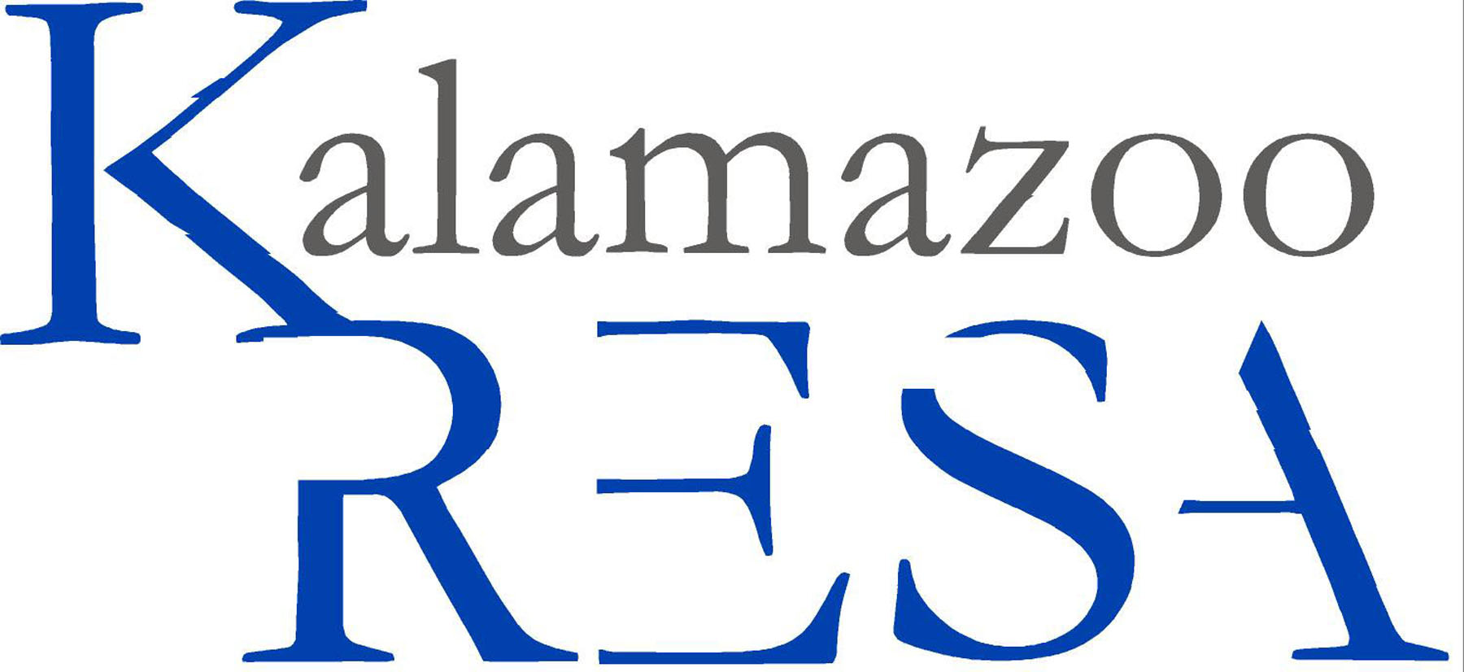
Kalamazoo Regional Educational Service Agency
Job Description

Job Title: Technology Support Specialist I
Reports To: Computer Support Manager
FLSA Status: Non-Exempt
Prepared By: Human Resources
Approved By: N/A
Prepared Date: 06/ 2005
Last Revised Date: 03/2016

Summary:
Installs, modifies, and makes minor repairs to personal computer hardware and software systems, and provides technical assistance and training to system users by performing the following duties.

Essential Duties and Responsibilities:
- Provides phone support for programs written and maintained by Kalamazoo RESA Technical Services Group and/or Internet services provided by Kalamazoo RESA
- Installs or assists service personnel in installation of hardware and peripheral components such as monitors, keyboards, printers and disk drives on user’s premises
- Loads specified software packages such as operating systems, word processing, or spreadsheet programs into computer
- Enters commands and observes system functions to verify correct system operation
- Responds to client inquiries concerning system operations and diagnoses system hardware, software, and operator problems
- Instructs users in use of equipment, software, and manuals
- Recommends or performs minor remedial actions to correct problems
- Reformats reports into the MiCase format
- Coordinates activities with help desk, network services, or other information systems groups
- Provides updates, status, and completion information to manager, problem request tracking system, and/or users, via voice mail, e-mail, or in-person communication
- Replaces defective or inadequate software packages
- Refers major hardware problems to service personnel for correction
- Utilizes WebEx remote control service to connect to customer computers to solve problems
- Tests software updates to ensure correct functionality and to keep informed of changes in software
- Makes minor modifications to Internet based systems and the Kalamazoo RESA website.
- Regular and consistent attendance
- Other duties may be assigned

Must have knowledge of and comply with the policies and procedures contained in the Kalamazoo RESA handbook.

Page 2 Job Title: Technology Support Specialist I

Education and/or Experience:
High school diploma or six months related experience and/or training; or equivalent combination of education and experience.

Certificates, License, Registration:
If applicable.

Other Skill & Abilities:
Ability to communicate effectively including listening
Works in a team oriented fashion
Ability to efficiently use computer and applicable software
Ability to problem solve
Ability to read, analyze and interpret data
Ability to write reports, correspondence and documentation
Effectively present information in front of groups and engage in audience
Adapts to frequent changes in the work environment
Practices safe work habits
Uses equipment and material properly

Supervisory Responsibilities:
This job has no supervisory responsibilities.

Physical Demands:
Reasonable accommodations may be made to enable individuals with disabilities to perform the essential functions. The employee is frequently required to reach with arms and hands, stand, walk and sit. The employee must frequently lift and/or move up to ten pounds and occasionally lift and/or move up to 25 pounds. Specific vision abilities required by this job include close vision, depth perception and ability to adjust focus.

Work Environment:
The noise level in the work environment is usually quiet.

The employee shall remain free of any alcohol or nonprescribed controlled substance in the workplace throughout his/her employment in the District.

It is the policy of Kalamazoo Regional Educational Service Agency that no discriminating practices based on gender/sex, sexual orientation, race, religion, height, weight, color, age, national origin, disability or any other status covered by federal, state or local law be allowed during any program, activity, service or in employment. The following positions at Kalamazoo RESA have been designated to handle inquiries regarding the nondiscrimination policy. Human Resources Director, Tom Zahrt; Assistant Superintendents: Margaret McGlinchey & Laurie Montgomery. Contact information: 269-250-9200, 1819 E. Milham Avenue, Portage, MI 49002.

